

How to …
Export your animation in DrawPlus X4 stop-frame mode and add sound in Movie maker.

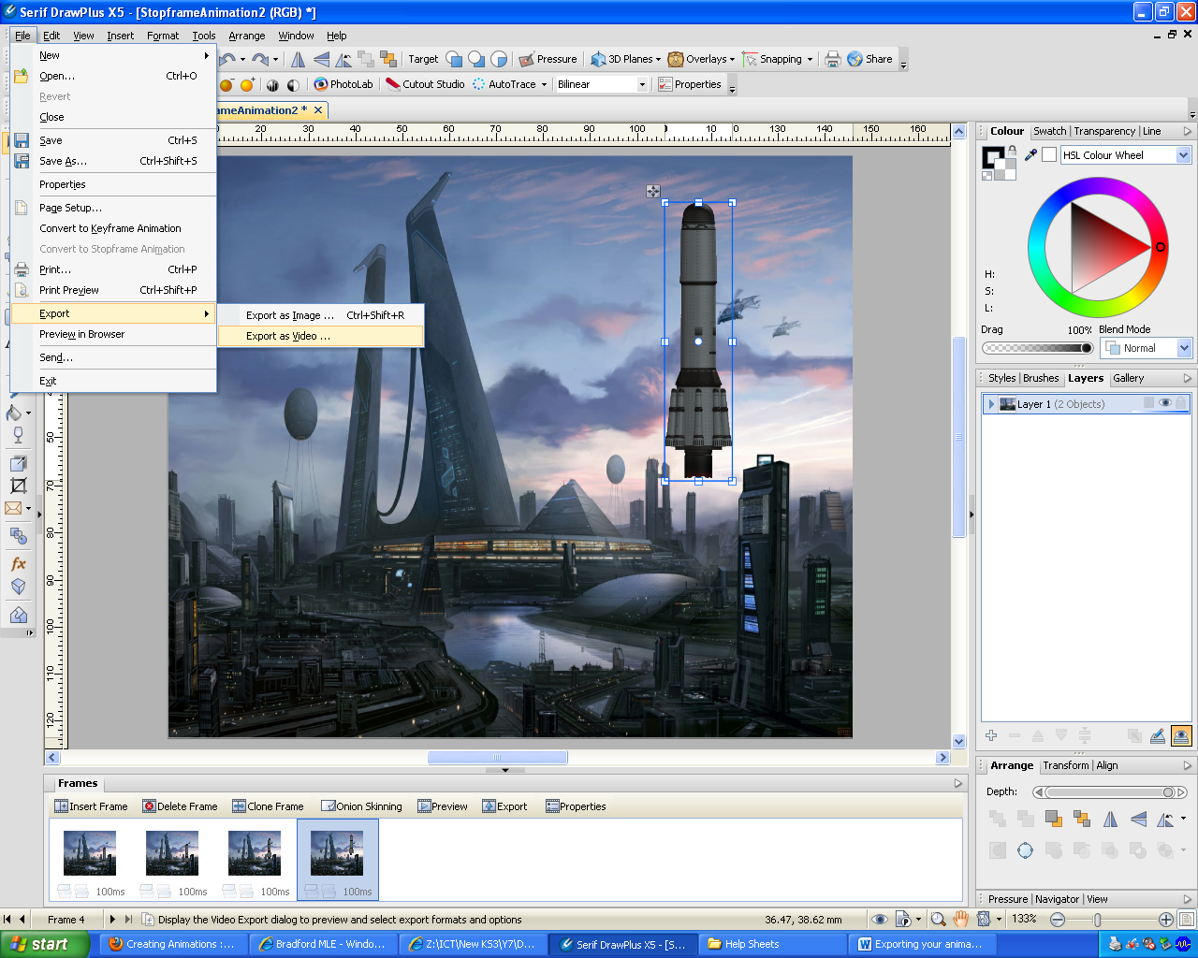

To export your animation you need to follow these steps:

- Click “File” then scroll down to “Export”
- Choose “Export as video”
- Then click export and save it into your Space folder

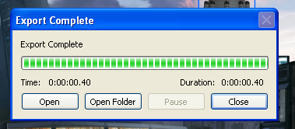
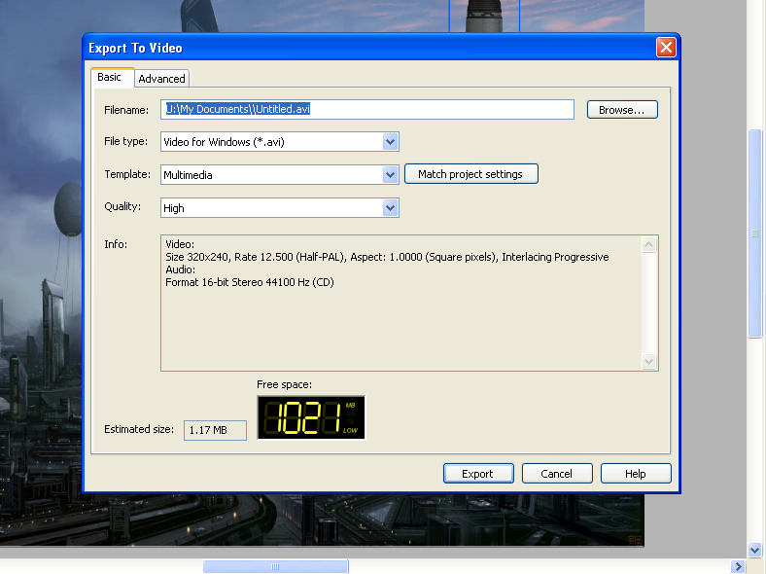
- Open “Movie Maker” by clicking on “Start” then “All Programs” then “Movie Maker”.

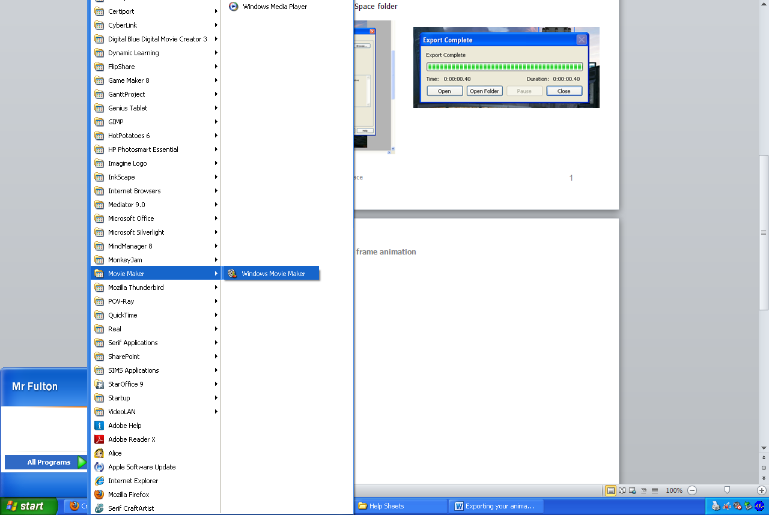

- Once movie maker is open inport your animation from your “Space” folder.

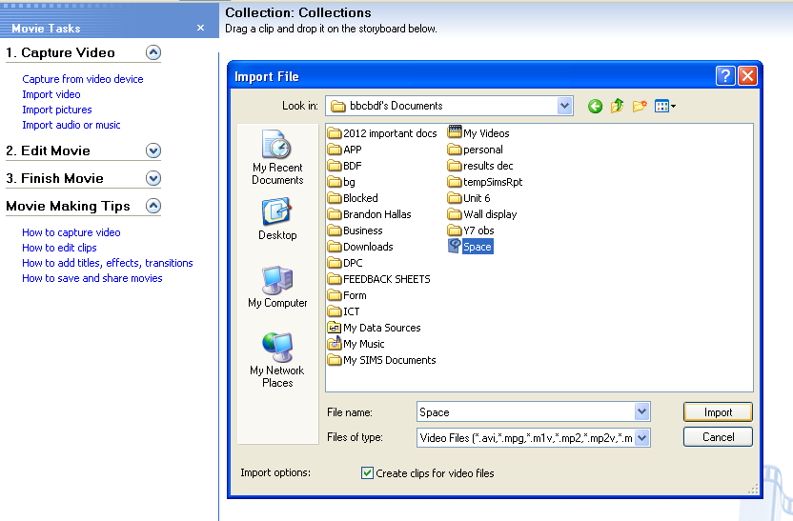
1.
2
3

- Drag clip onto storyboard.
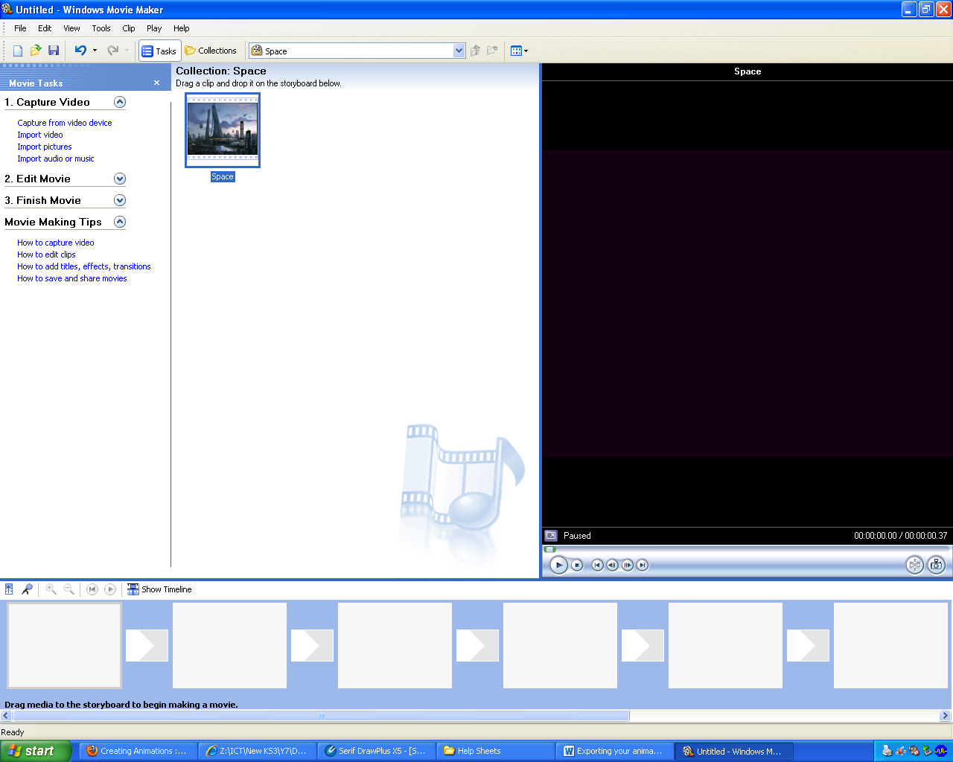
Then press “Time Line” button.
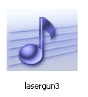
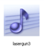
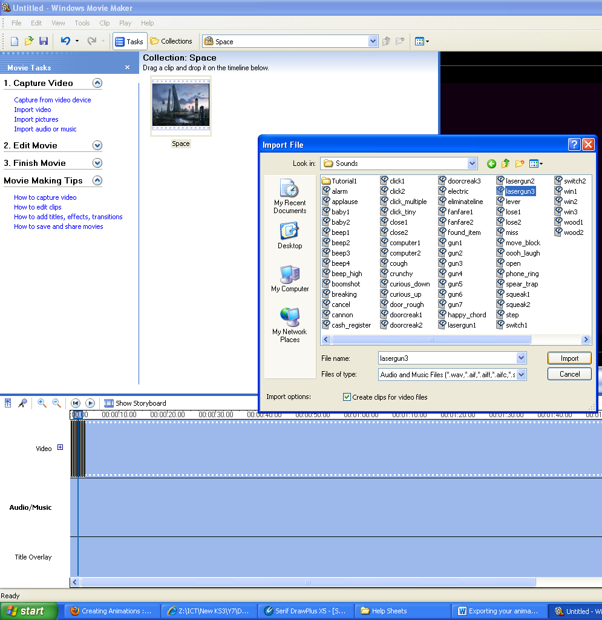
1.
2
3

- Select the music or sound you want and drag the file from your captue area down to your timeline here.

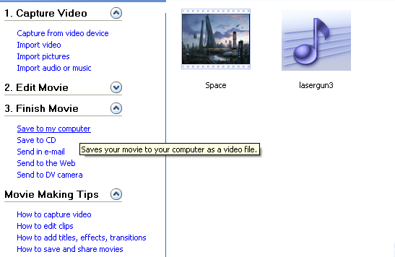
8. Press play to check audio and video. If you are happy with it then click “Finish Movie” & “save to computer

